Setup Lambok to the STS in mac
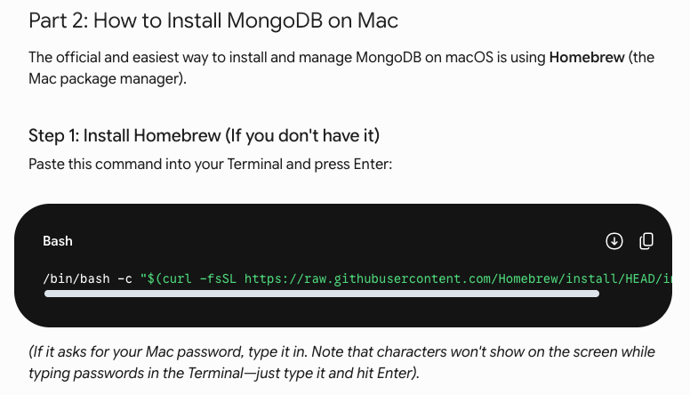

>> /bin/bash -c "$(curl -fsSL https://raw.githubusercontent.com/Homebrew/install/HEAD/install.sh)"

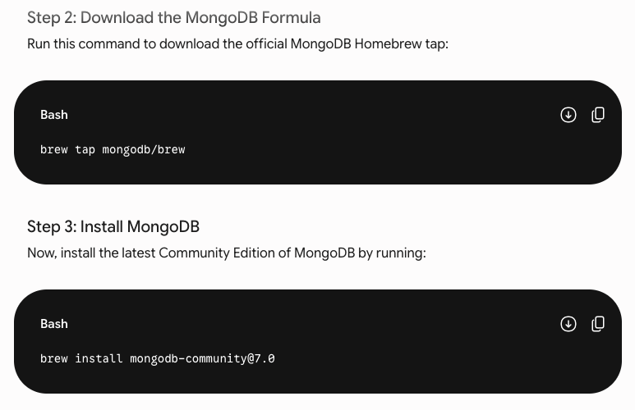
>> brew tap mongodb/brew
>> brew install mongodb-community@7.0

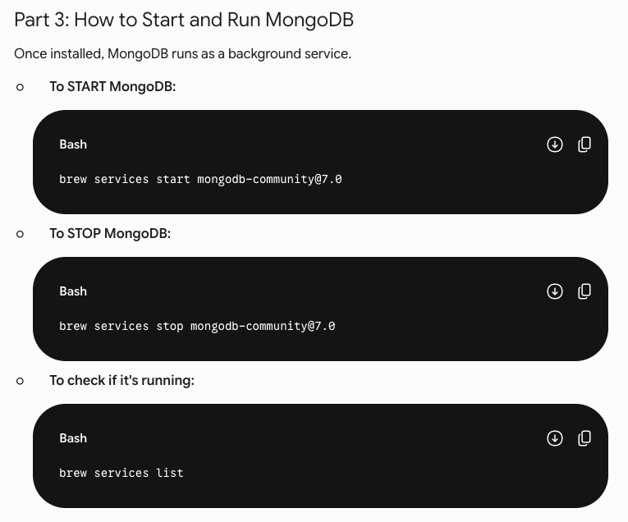
>> brew services start mongodb-community@7.0
>> brew services stop mongodb-community@7.0
>> brew services list
>> mongosh

